|  |  |  |  |  |
| --- | --- | --- | --- | --- |
| **National University of Computer and Emerging Sciences, Lahore Campus** | | | | |
| final design | **Course:** | **OOAD Lab** | **Course Code:** | **CL118** |
| **Program:** | **BS(Computer Science)** | **Semester:** | **Fall 2018** |
| **Duration:** | **30 Minutes** | **Total Marks:** | **5+5+5** |
| **Paper Date:** | **27-Nov-18** | **Weight** | **5** |
| **Section:** | **B** | **Page(s):** | **1** |
| **Exam:** | **Quiz-2** |  |  |
| **Instruction/Notes:** |  | | | |

**Task 1: (GUI) 5 MARKS**

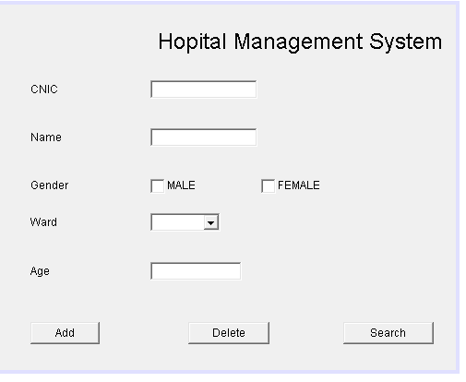

**Task 2: (5 Marks)**

Create a class Patient having following data members.

* cnic
* name
* Gender
* Ward
* Age

Now create an class with name as Record Patients. This class has the following data members.

* List<Patients > Patients

**Functions**

1. Boolean Add_Patient (Patient m)

* This function will take Patient object and add them to the list.
* Returns true in case of success.

1. Boolean Delete_Patient (String CNIC)

* This function will take Patient cnic and search for it in the list and delete the record in case of record found and return true.

1. Boolean Search (String CNIC)

* This function will take Patient and search for it in the list and if found returns true.

**Task 3: (5 Marks)**

For the GUI you have built in task 1 you have to implement event listeners for buttons Add, delete and Search using task2 functions you have implemented.